Appendix A

Survey questionnaire items

Ethnic identity scale
A five-point Likert-type scale ranging from highly disagree (1) to highly agree (5).
1. I am glad to be a member of my nation.
2. I feel strong ties with members of my nation
3. Belonging to my nation is very important to me.
4. I feel that I belong to my nation.
5. Belonging to my nation makes me proud.

Ethnonationalism scale items
A five-point Likert-type scale ranging from highly disagree (1) to highly agree (5).
1. My nation is better than other nations.
2. I would rather belong to my nation than any other nation.
3. In all historical conflicts with other nations my nation was always right.

Perceived symbolic threat scale items
A four-point scale ranging from highly disagree (1) to highly agree (4).
1. My [out-group] peers do not respect the language of my nation.
2. My [out-group] peers should not overemphasize their national symbols and customs.
3. My [out-group] peers are listening the music that bothers us.
4. My [out-group] peers think they are better than we are.
5. My [out-group] peers are name-calling us because we are of different nationality.

Intergroup anxiety
A five-point scale ranging from not at all (1) to extremely (5). It consisted of six items that ask participants how they would feel when interacting with members of the other ethnic group (e.g. having a conversation with them, collaborating on a school task, etc.).
1. Comfortable
2. Nervous
3. Friendly
4. Uncertain
5. Worried
6. Equal

The tendency for out-group discrimination scale
Yes/no responses.
1. If the teacher asked me to help one of two students who were absent from school by taking homework to them, I would choose to take the homework to the [in-group member] even if the [out-group member] lived closer to my home.
2. If I had to choose which students would be picked for a school sports team, I would rather pick the [in-group member] even if the [out-group member] was better at sports.
3. If I liked some girl/boy that I do not know, I would approach her/him only if she/he was of my nationality.
4. In an important mathematics competition I would rather work in pair with the [in-group member], although I know that the [out-group member] is better mathematician.
5. If I had forgotten to bring school supplies to school, I would borrow it only from the [in-group member].
6. If I had forgotten to do my homework, I would rather get a bad mark than to copy homework from the [out-group member].
7. On a school trip, I would rather share a room with the [in-group member], although I know that the [out-group member] is more fun.
8. I would accept friend request on the social media/Facebook only if it was from [in-group member].

The Active bystander scale
How would you act in these situations?
Indicate your most probable reaction on a four-point scale: support them or join them (1), ignore them (2), ask them to stop (3), and ask my peers to help me to make it stop (4).
1. When my peers spread lies or gossip [out-group students]
2. When my peers call [out-group students] names
3. When my peers provoke [out-group students] with overemphasizing national symbols
4. When my peers threaten [out-group students]
5. When my peers get into fight with [out-group students]

Appendix B

Table 1
Correlations, means and standard deviations for the main variables for the whole sample
 | M | SD | 1. | 2. | 3. | 4. | 5. | 6. | 7.
1. Group status | - | - | 1
2. Ethnic identity | 4.16 | 0.86 | -.04 | 1
3. Ethnonationalism | 2.67 | 1.07 | .01 | .52** | 1
4. Perceived symbolic threat | 1.92 | 0.78 | .15** | .03 | .25** | 1
5. Intergroup anxiety | 1.80 | 0.71 | .03 | -.02 | .22** | .51** | 1
6. Tendency for discrimination | 1.16 | 1.80 | .07** | .16** | .34** | .32** | .38** | 1
7. Tendency for prosocial behavior | 2.96 | 0.66 | .01 | .01 | -.24** | -.38** | -.36** | -.22** | 1
Note. The range of ratings for each measure is as follows: group status, 1-majority 2-minority; ethnic identity, 1-5; ethnonationalism, 1-5; perceived symbolic threat, 1-4; intergroup anxiety, 1-5; tendency for discrimination, 0-no 1-yes; tendency for prosocial behavior, 1-4
** p < .01

Table 2
Direct and indirect effects of ethnic identity and ethnonationalism on the tendency for discrimination and for prosocial behavior for the whole sample
 | Tendency for discrimination Model A (N = 986) | Tendency for prosocial behavior  Model B (N = 985)
Ethnic identity
Direct effect | 0.08 [-0.04, 0.19] | 0.06 [0.01, 0.10]
Indirect effect via symbolic threat | -0.02 [-0.05, -0.01] | 0.02 [0.01, 0.04]
Indirect effect via intergroup anxiety | -0.09 [-0.16, -0.05] | 0.03 [0.01, 0.04]
Ethnonationalism
Direct effect | 0.38 [0.27, 0.49] | -0.12 [-0.16, -0.08]
Indirect effect via symbolic threat | 0.06 [0.02, 0.10] | -0.05 [-0.07, -0.03]
Indirect effect via intergroup anxiety | 0.14 [0.09, 0.21] | -0.04 [-0.06, -0.02]
Total effect | 0.54 [0.41, 0.67] | -0.11 [-0.16, -0.05]
Note. Coefficients are standardized, bootstrapped 95% BCa CI in parentheses.
Significant coefficients are bolded.

Table 3
Summary of fit statistics for the multiple group path model for group status – ethnic majority and minority

Model | df | Χ² | Δ Χ² | Δ df | p
Model A. Tendency for discrimination
Unconstrained model | 0 | 0.00
Constrained model | 8 | 10.10 | 10.10 | 8 | .26
Model B. Tendency for the prosocial behavior
Unconstrained model | 0 | 0.00
Constrained model | 8 | 14.73 | 14.73 | 8 | .07
Note. Unconstrained model – all path coefficients in the model are free, constrained model – all path coefficients are equal for majority and minority
** p < .01; * p < .05

Table 4
Summary of fit statistics for the multiple group path model for group status – ethnic majority and minority in different social contexts
Social context | Model |  | df | Χ² | Δ Χ² | Δ df | p
Serb-Croat context | Model A. Tendency for discrimination
 | Unconstrained model |  | 0 | 0.00
 | Constrained model |  | 8 | 8.78 | 8.78 | 8 | .36
 | Model B. Tendency for the prosocial behavior
 | Unconstrained model |  | 0 | 0.00
 | Constrained model |  | 8 | 10.49 | 10.49 | 8 | .23
Hungarian-Croat context | Model A. Tendency for discrimination
 | Unconstrained model |  | 0 | 0.00
 | Constrained model |  | 8 | 14.08 | 14.08 | 8 | .08
 | Model B. Tendency for the prosocial behavior
 | Unconstrained model |  | 0 | 0.00
 | Constrained model |  | 8 | 12.54 | 12.54 | 8 | .13
Czech-Croat context | Model A. Tendency for discrimination
 | Unconstrained model |  | 0 | 0.00
 | Constrained model |  | 8 | 21.41 | 21.41 | 8 | .01**
 | Model B. Tendency for the prosocial behavior
 | Unconstrained model |  | 0 | 0.00
 | Constrained model |  | 8 | 17.98 | 17.98 | 8 | .02*
Italian-Croat context | Model A. Tendency for discrimination
 | Unconstrained model |  | 0 | 0.00 | 3.51 | 8
 | Constrained model |  | 8 | 3.51 |  |  | .90
 | Model B. Tendency for the prosocial behavior
 | Unconstrained model |  | 0 | 0.00
 | Constrained model |  | 8 | 9.44 | 9.44 | 8 | .31
Note. Unconstrained model – all path coefficients in the model are free, constrained model – all path coefficients are equal for majority and minority
** p < .01; * p < .05

Appendix C

Figure 4
Path diagram of mediation model for the for the subsample in the Serb-Croat context, Model A
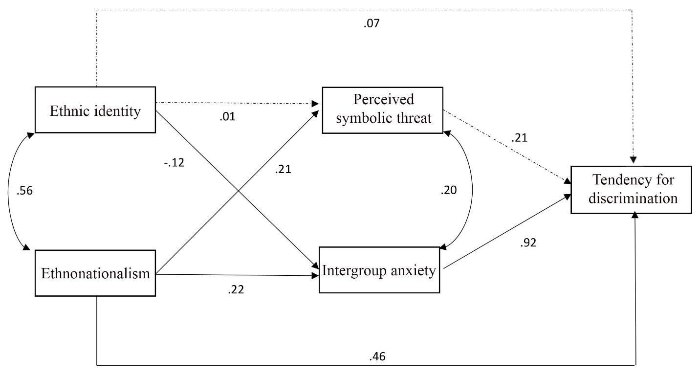
Note. Path coefficients are standardized regression weights. Path coefficients displayed with solid lines are significant, 95% confidence intervals did not include zero. Path coefficients displayed with dotted lines are nonsignificant. Model explained 32.7% of the variance.

Figure 5
Path diagram of mediation model for the for the subsample in the Serb-Croat context, Model B
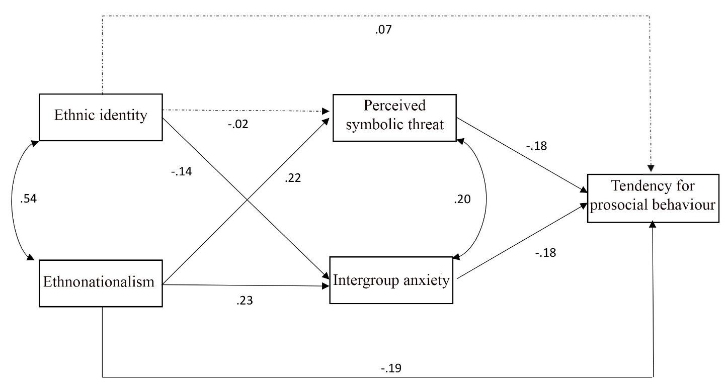
Note. Path coefficients are standardized regression weights. Path coefficients displayed with solid lines are significant, 95% confidence intervals did not include zero. Path coefficients displayed with dotted lines are nonsignificant. Model explained 25.7% of the variance.

Figure 6
Path diagram of mediation model for the for the subsample in the Hungarian-Croat context, Model A
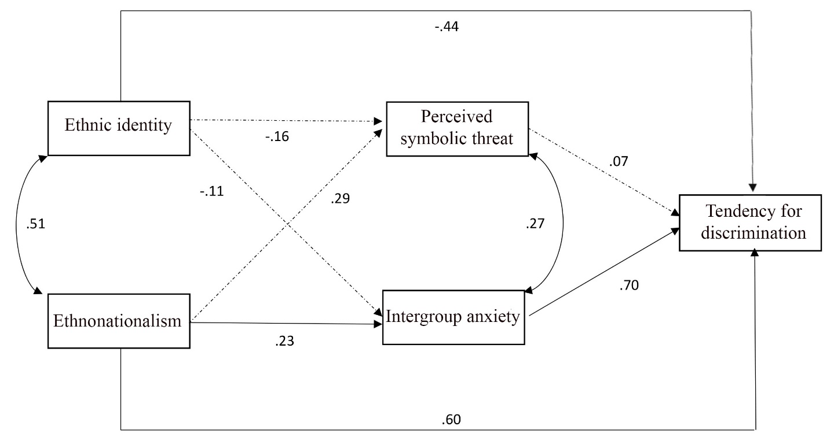
Note. Path coefficients are standardized regression weights. Path coefficients displayed with solid lines are significant, 95% confidence intervals did not include zero. Path coefficients displayed with dotted lines are nonsignificant. Model explained 22.6% of the variance.

Figure 7
Path diagram of mediation model for the for the subsample in the Hungarian-Croat context, Model B
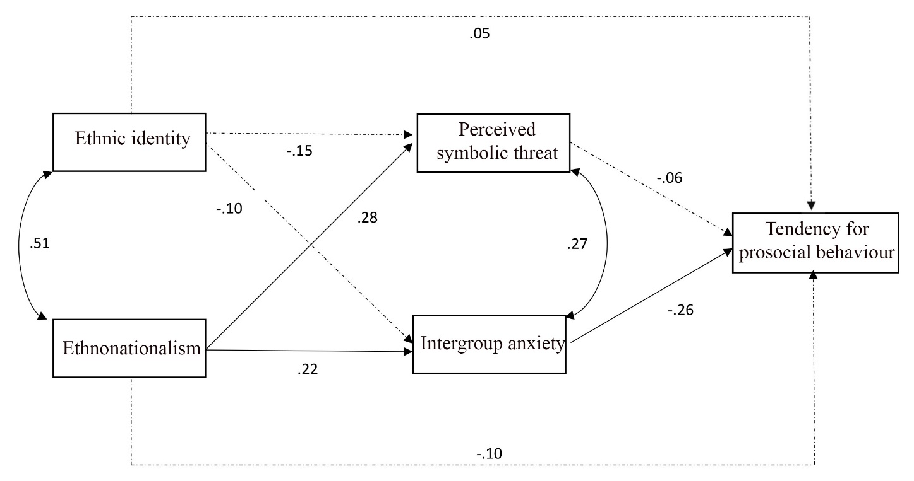
Note. Path coefficients are standardized regression weights. Path coefficients displayed with solid lines are significant, 95% confidence intervals did not include zero. Path coefficients displayed with dotted lines are nonsignificant. Model explained 19.1% of the variance.

Figure 8
Path diagram of mediation model for the for the subsample in the Italian-Croat context, Model A
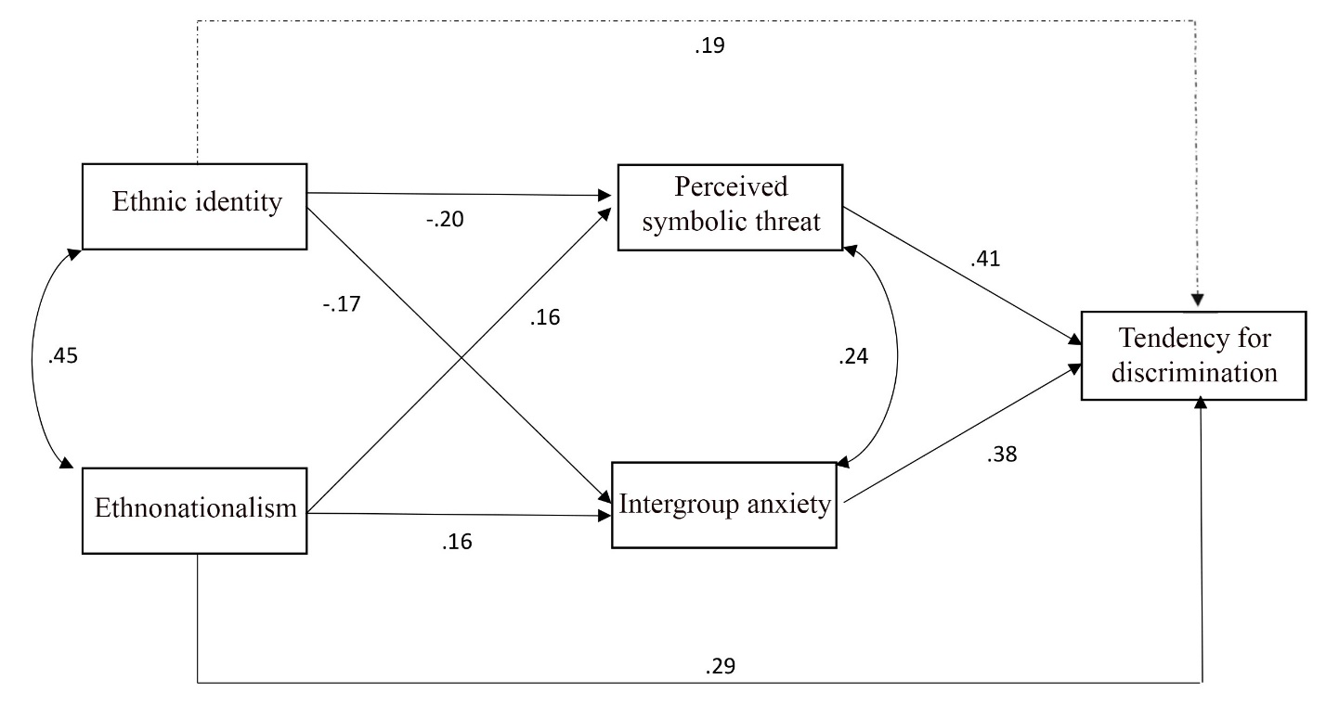
Note. Path coefficients are standardized regression weights. Path coefficients displayed with solid lines are significant, 95% confidence intervals did not include zero. Path coefficients displayed with dotted lines are nonsignificant. Model explained 14.8% of the variance.

Figure 9
Path diagram of mediation model for the for the subsample in the Italian-Croat context, Model B
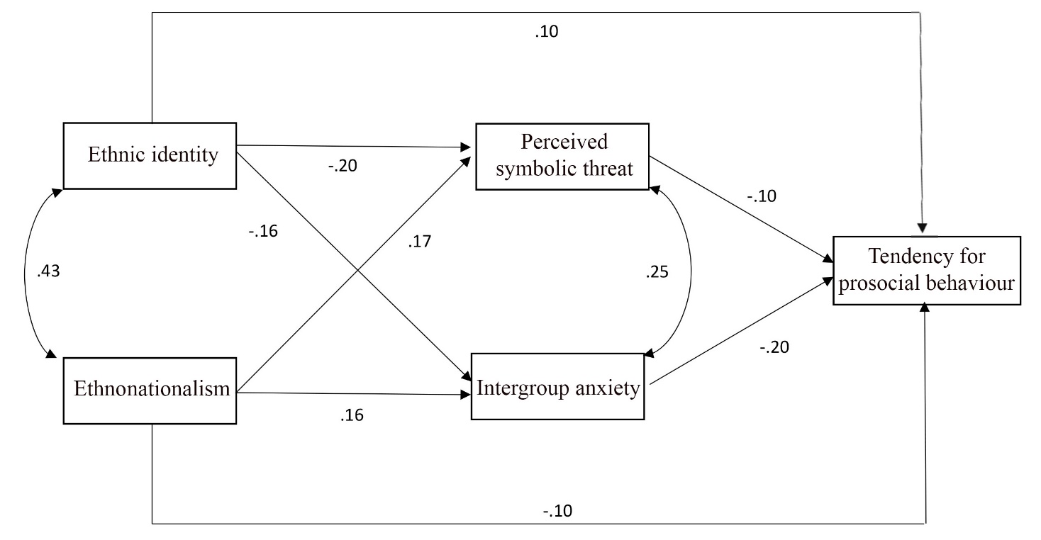
Note. Path coefficients are standardized regression weights. Path coefficients displayed with solid lines are significant, 95% confidence intervals did not include zero. Path coefficients displayed with dotted lines are nonsignificant. Model explained 14.3% of the variance.

